POCKETSMART AI

AI-Powered Personal Planning Assistant

Project team members:
1.Varshini M (2522k0610)
2.Vidhya S (2522k0611)
3.Sathys G (2522k0609)
4.Vikashini P (2522k0612)

Department of Computer Science

[Navarasam Arts And Science College For Women]
Academic Year 2025-2028

AI-Powered Personalized Planning and Recommendation System

1. ABSTRACT
PocketSmart AI is an AI-powered web application designed to provide personalized planning and recommendation services based on user requirements, budget, preferences, and selected planning categories.

The system provides different planners such as Home Planning, Party Planning, and Jewelry Planning. Users can create an account, log in securely, select a planner, enter their requirements, and generate a personalized plan.
The application uses FastAPI as the backend framework, SQLite as the database, and Google's Gemini API for AI-powered recommendations. The system also provides budget breakdowns and practical suggestions to help users make better planning decisions.
The main objective of PocketSmart AI is to combine budgeting, personalized recommendations, and artificial intelligence into a simple and user-friendly web application.

2. INTRODUCTION
Planning an event, home, or personal purchase often requires considerable time, budget estimation, and decision-making. Users may find it difficult to organize their requirements and identify suitable options within their available budget.
PocketSmart AI is developed to solve this problem by providing an intelligent planning system. The application collects user inputs such as budget, requirements, preferences, occasion, number of guests, rooms, style, and other relevant details.
Based on these inputs, the system generates a personalized plan. Gemini AI is integrated into the application to provide intelligent suggestions and practical recommendations.

3. PROBLEM STATEMENT
Users often need to manually search for ideas, calculate budgets, compare options, and organize planning details.
The main problems include:
- Difficulty in creating a proper plan.
- Lack of personalized recommendations.
- Difficulty in managing budgets.
- Time-consuming manual research.
- Lack of a single platform for different planning requirements.
- Difficulty in generating recommendations based on individual preferences.
PocketSmart AI addresses these problems by providing an integrated AI-based planning and recommendation platform.

4. OBJECTIVES
The main objectives of PocketSmart AI are:
- To develop an AI-powered personalized planning system.
- To provide recommendations based on user requirements.
- To help users plan within a selected budget.
- To provide budget breakdowns where applicable.
- To provide different planning categories.
- To securely manage user registration and login.
- To store generated recommendations for users.
- To integrate Gemini AI for intelligent suggestions.
- To provide a simple and user-friendly interface.

5. EXISTING SYSTEM
In the existing system, users generally depend on search engines, social media, websites, or manual calculations to prepare their plans.

Disadvantages of Existing System
- Requires manual research.
- Recommendations may not be personalized.
- Budget calculation may require separate tools.
- Information is available across multiple platforms.
- Users need to compare different options manually.

6. PROPOSED SYSTEM
The proposed system, PocketSmart AI, provides a centralized platform for personalized planning.
Users can:
- Create an account.
- Log in securely.
- Select a planner.
- Enter their requirements.
- Enter their budget.
- Generate an AI-powered plan.
- View suggestions.
- View budget-related information.
- Store recommendation results.
The system uses Gemini AI to generate personalized suggestions based on the information provided by the user.

7. SYSTEM REQUIREMENTS

Hardware Requirements
- Computer/Laptop
- Minimum 4 GB RAM
- Internet connection
- Keyboard and mouse
- Sufficient storage space

Software Requirements
- Windows/Linux/macOS
- Python 3.x
- Visual Studio Code
- FastAPI
- Uvicorn
- SQLite
- Google Gemini API
- Modern web browser

8. TECHNOLOGIES USED

Python
Python is used as the primary programming language for backend development.

FastAPI
FastAPI is used to develop the web application's backend and API routes.

SQLite
SQLite is used as the database for storing user information and recommendation records.

Gemini AI
Google Gemini API is integrated to generate AI-powered planning suggestions.

HTML/CSS
HTML and CSS are used to create and style the application's web pages.

JavaScript
JavaScript can be used for client-side interactions and dynamic behaviour.

Uvicorn
Uvicorn is used as the ASGI server to run the FastAPI application.

9.SYSTEM ARCHITECTURE
The overall architecture of PocketSmart AI consists of the following components:

User
↓
Web Interface
↓
FastAPI Backend
↓
Authentication / Planner Routes
↓
Recommendation Service
↓
Gemini AI
↓
Generated Recommendation
↓
SQLite Database

The user provides planning information through the web interface. FastAPI receives the request and sends the relevant information to the recommendation service. The recommendation service processes the information and, when applicable, sends a prompt to Gemini AI.
The generated result is returned to the application and stored in the SQLite database.

10. MODULES

10.1 User Authentication Module
This module manages user registration and login.
Functions include:
- User registration
- Password hashing
- Password verification
- Login authentication
- Access token generation
- Current user verification
- Logout/session management

10.2 Home Planner Module
The Home Planner allows users to create a home planning recommendation.
The user can provide:
- Budget
- Rooms
- Home style
- Priorities
The system generates:
- Home planning suggestions
- Furniture suggestions
- Lighting suggestions
- Storage suggestions
- Budget breakdown
- Budget-saving ideas

10.3 Party Planner Module
The Party Planner generates recommendations based on party requirements.
User inputs include:
- Budget
- Number of guests
- Event type
- Venue
- Preferences
The system provides:
- Party planning suggestions
- Food suggestions
- Decoration suggestions
- Budget-saving ideas
- Entertainment suggestions

10.4 Jewelry Planner Module
The Jewelry Planner generates recommendations based on:
- Budget
- Occasion
- Style
The system provides:
- Jewelry type suggestions
- Suitable design suggestions
- Budget-friendly recommendations
- Matching tips
- Styling suggestions

10.5 AI Recommendation Module
This is the main intelligent component of PocketSmart AI.
The system creates a prompt using the user's information and sends it to Gemini AI.
The generated response is then displayed as personalized suggestions.

10.6 Database Module
SQLite is used to store application data.
The main tables include:

Users Table
- id
- name
- email
- password_hash
- created_at

Recommendations Table
- id
- user_id
- planner
- input_json
- result_json
- created_at

11. DATABASE DESIGN
The users table stores registered user information.
The recommendations table stores generated planner results.
There is a relationship between the two tables through user_id.
Relationship:
Users (1) → Recommendations (Many)
One user can have multiple recommendation records.

12. SYSTEM IMPLEMENTATION
The backend application is organized into different components.

Configuration
The configuration module manages:
- Application name
- Secret key
- Database URL
- Gemini API key
- Gemini model
- Token expiration
- CORS settings

Authentication
The authentication module manages password hashing, password verification, token creation, and current-user authentication.

Database
The database module creates and manages SQLite database connections and tables.

Routes
Routes handle requests such as:
- Registration
- Login
- Dashboard
- Planner requests
- Recommendation generation

Recommendation Service
The recommendation service processes planner inputs and generates the final result.

13. AI INTEGRATION
PocketSmart AI integrates Google's Gemini API for intelligent recommendations.
The application sends a structured prompt containing the user's planning information.
For example, a home planning prompt may contain:
- Budget
- Rooms
- Style
- Priorities
Gemini AI processes the prompt and generates practical recommendations.
The generated response is then displayed to the user as part of the planner result.

14. AUTHENTICATION AND SECURITY
The application provides user authentication to protect user-specific information.
Passwords are not stored directly. They are converted into secure password hashes before being stored in the database.
The application uses authentication tokens to identify logged-in users.
The system also verifies the current user before accessing protected resources.
The Gemini API key is maintained through application configuration/environment settings instead of displaying it directly in the application's user interface.

15. TESTING

The application can be tested using different test cases.
Test Case | Expected Result
Create account with valid details | Account created successfully
Login with valid credentials | User logged in
Login with incorrect password | Authentication error
Generate Home Plan | Home recommendation displayed
Generate Party Plan | Party recommendation displayed
Generate Jewelry Plan | Jewelry recommendation displayed
Enter budget | Budget information processed
Gemini API available | AI suggestions generated
Gemini API unavailable | Fallback message displayed
Open protected page without login | Authentication required

16. USER INTERFACE SCREENSHOTS

Figure 1: Home Page
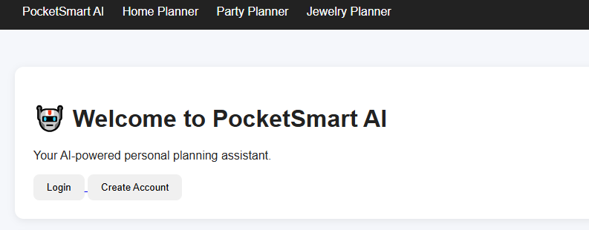

Figure 2: Registration Page
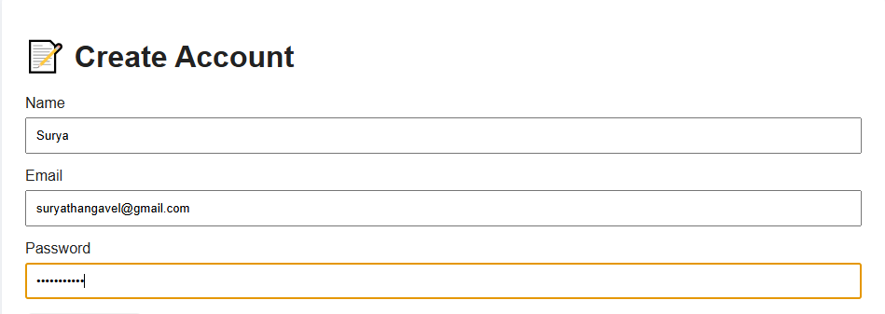

Figure 3: Dashboard

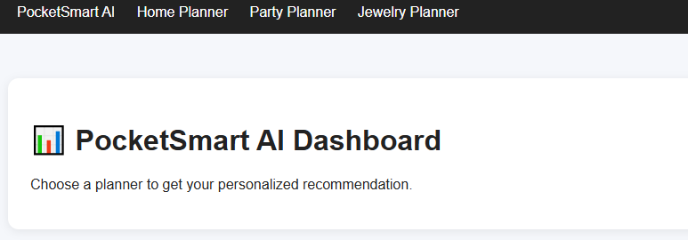


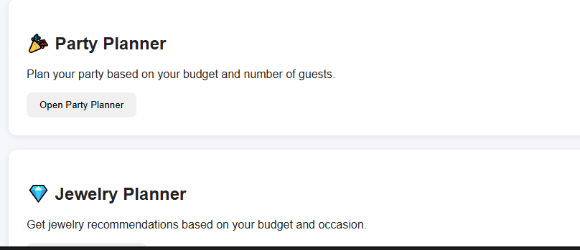

Figure 4: Home Planner
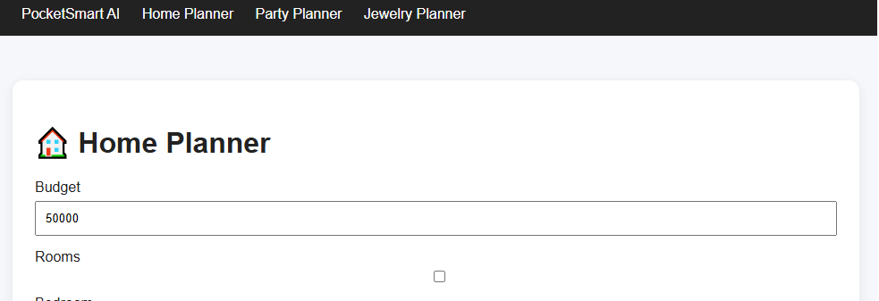
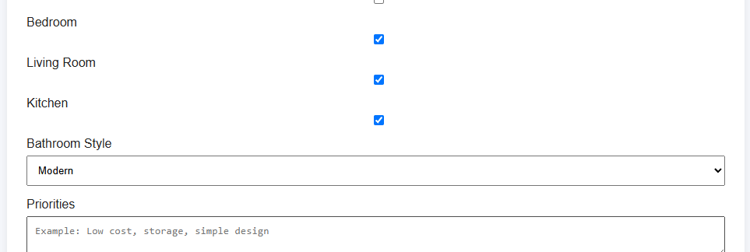

Figure 5: Home Planner Result:
- Home Plan
- Plan Details
- Budget Breakdown
- Suggestions




Figure 6: Party Planner

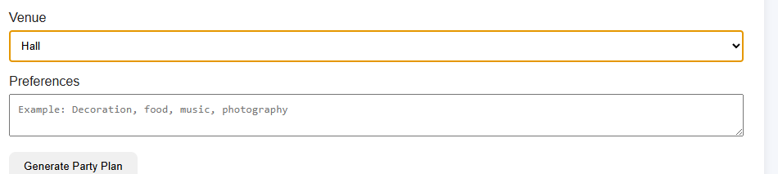

Figure 7: Party Planner Result

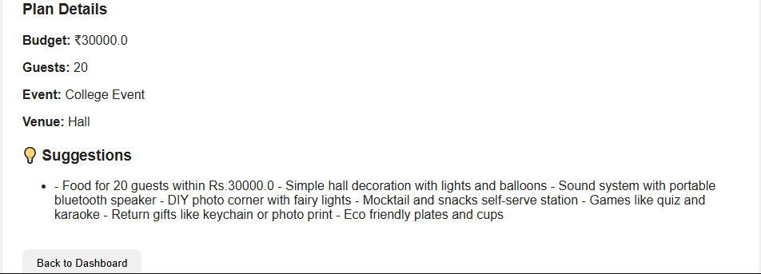

Figure 8 : Jewelry Planner

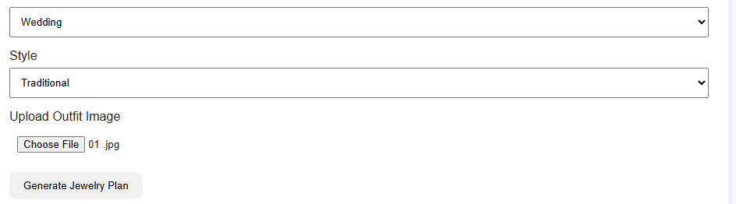

Figure 9: Jewellery planner Result





Figure 10: AI Recommendation





17. ADVANTAGES
- Easy-to-use planning system.
- AI-powered recommendations.
- Personalized suggestions.
- Budget-oriented planning.
- Multiple planning categories.
- User authentication.
- Recommendation storage.
- Reduces manual planning effort.
- Centralized platform.

18. LIMITATIONS
- AI recommendations depend on the availability of the Gemini API.
- Internet connectivity is required for AI-generated recommendations.
- Recommendations are generated based on the information provided by the user.
- The current system provides planning suggestions rather than direct purchasing or booking services.

19. FUTURE ENHANCEMENTS
Future versions of PocketSmart AI can include:
- More planner categories.
- Image-based recommendations.
- Voice-based input.
- Advanced budget analytics.
- Recommendation history and comparison.
- Export plans as PDF.
- Personalized user profiles.
- Improved dashboard analytics.
- Mobile application support.
- More advanced AI-based personalization.

20. CONCLUSION
PocketSmart AI is an AI-powered personalized planning and recommendation system that combines budgeting, user preferences, authentication, database management, and artificial intelligence.
The application provides different planning categories such as Home, Party, and Jewelry. Users can enter their requirements and receive personalized suggestions through Gemini AI.
The project demonstrates how modern web technologies and artificial intelligence can be combined to create a practical and user-friendly planning application.
PocketSmart AI provides a foundation that can be further extended with additional planners, advanced AI capabilities, analytics, and mobile support.

21. REFERENCES
- Python Documentation
- FastAPI Documentation
- SQLite Documentation
- Google Gemini API Documentation
- Uvicorn Documentation
- Pydantic Settings Documentation
- HTML, CSS and JavaScript Documentation

